Final Project Design Phase
Computer Science - Week 11
Oct 3, 2026 - Version 0.0.4

For complete instructions and project ideas, refer to the assignment in Canvas. Specifically, review the final project requirements before you continue below. If you have not reviewed the project requirements in Canvas (you might have to go to the modules view and check the current or past week's content), you will not be able to properly complete the parts below. In addition, it may be helpful to review the information on this Drafter documentation page.

0) Project Planning and Preparation
Successful programmers spend time planning before they begin coding. After reviewing the project requirements, answer the following questions to help guide your design and development process.
- What concepts from class or previous assignments might help you complete this project? Which programming concepts (loops, conditionals, lists, classes, etc.) do you expect to use? What programming skills do you want to improve while completing this project?
Some concepts from class or another assignment that might help me complete the project requirements is using custom dataclasses for the State in Drafter and also using conditional if statements to evaluate some of the password complexity rules like its length, uppercase/lowercase letters, digits, and special characters. I will use loops to manage the state via Drafter to save user input across pages. I want to improve my UI routing in Drafter.

- Which parts of the project do you expect to be the easiest for you? The hardest? Why?
Setting up the basic routing through the pages and making simple input boxes should be some of the easier tasks because they use Drafter templates but the logic to evaluate the password strength and writing clear documentation of this process will be the most challenging.

- Even though you have not yet designed the final project, estimate which tasks will likely require the most time and effort? Which features or components should be implemented first?
The features/components that will require the most time is the validation logic of the password and also the password brute force cracking time implementation. The things that should be implemented first however are the main basic layout of the website so the main input page and routing to the results page and main inputs.

- What distractions might interfere with your work and how will you minimize them? What resources will you need available while working? What questions, if any, do you still have about the assignment requirements?
Friends, other school work, and basic needs might interfere with my work. I will minimize them by making sure to eat good before I work so I wont have to pause my work and then get more off task. For the other parts if I get stuck on this task I might do some other homework and come back to it and with friends I’ll make time to hangout once I’ve done my portion for the day.

1) Site Diagram
Create a mock-up of your planned website. We suggest you make the mockup on paper, although you can also use software like PowerPoint or Slides to make a mockup. There is other design software that could also be used, but we strongly encourage you to keep it simple. Do not spend more than 15-30 minutes detailing the mock-up. Your goal should be to make a very quick and dirty diagram, to show that you have some kind of idea.

We recommend drawing each page as a rectangle, and laying out the text, buttons, and other components inside. Then, use arrows to indicate links between pages. Label each page the way you will name each function, and then put labels on the arrows to indicate what the button links. Also write down any parameters that should come into the pages.

In addition to the pages and routes, write down what fields your `State` will have, both their names and types. Think clearly about what data will need to be persistent across the entire website.

Add photo(s) or screenshot(s) of your website mock-up and labeled diagram on the next page.
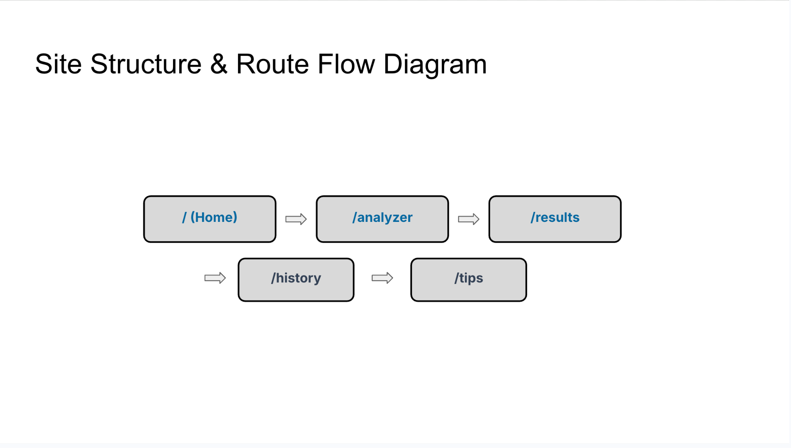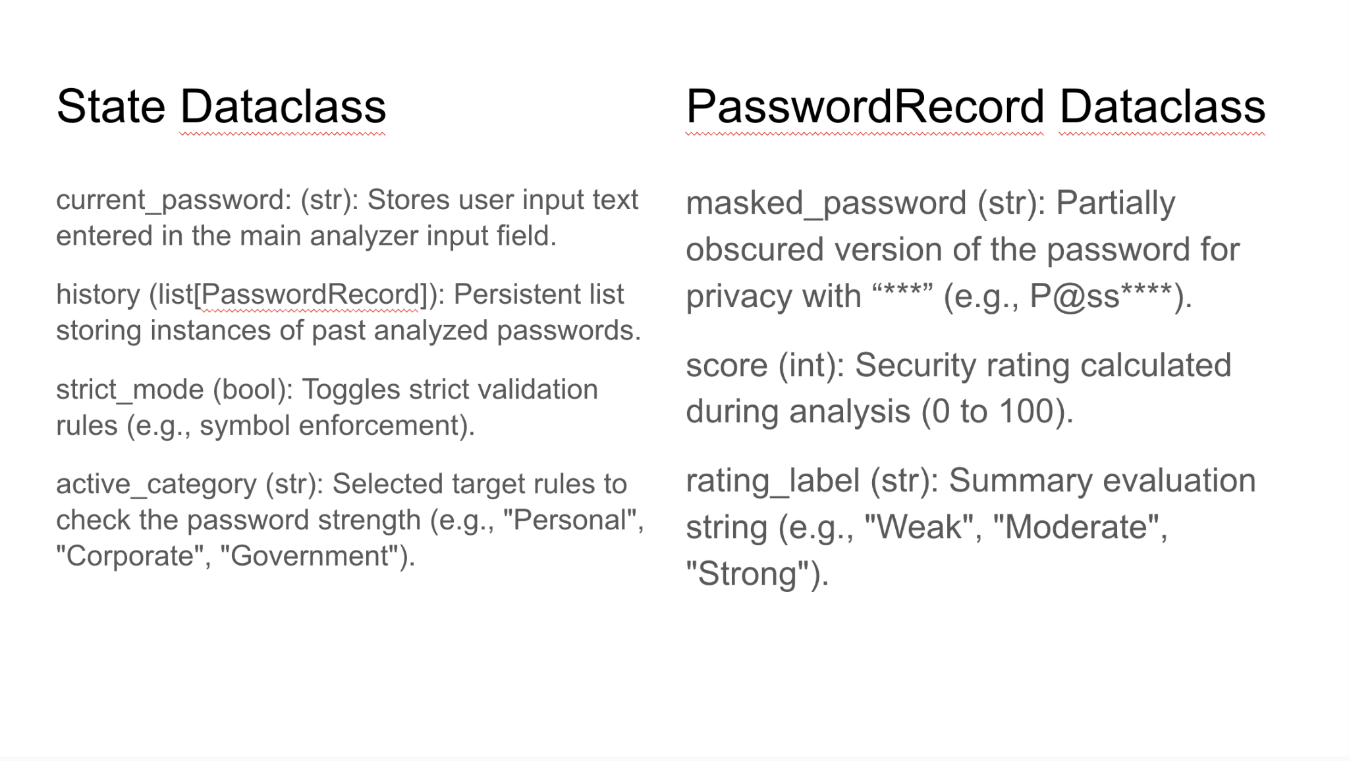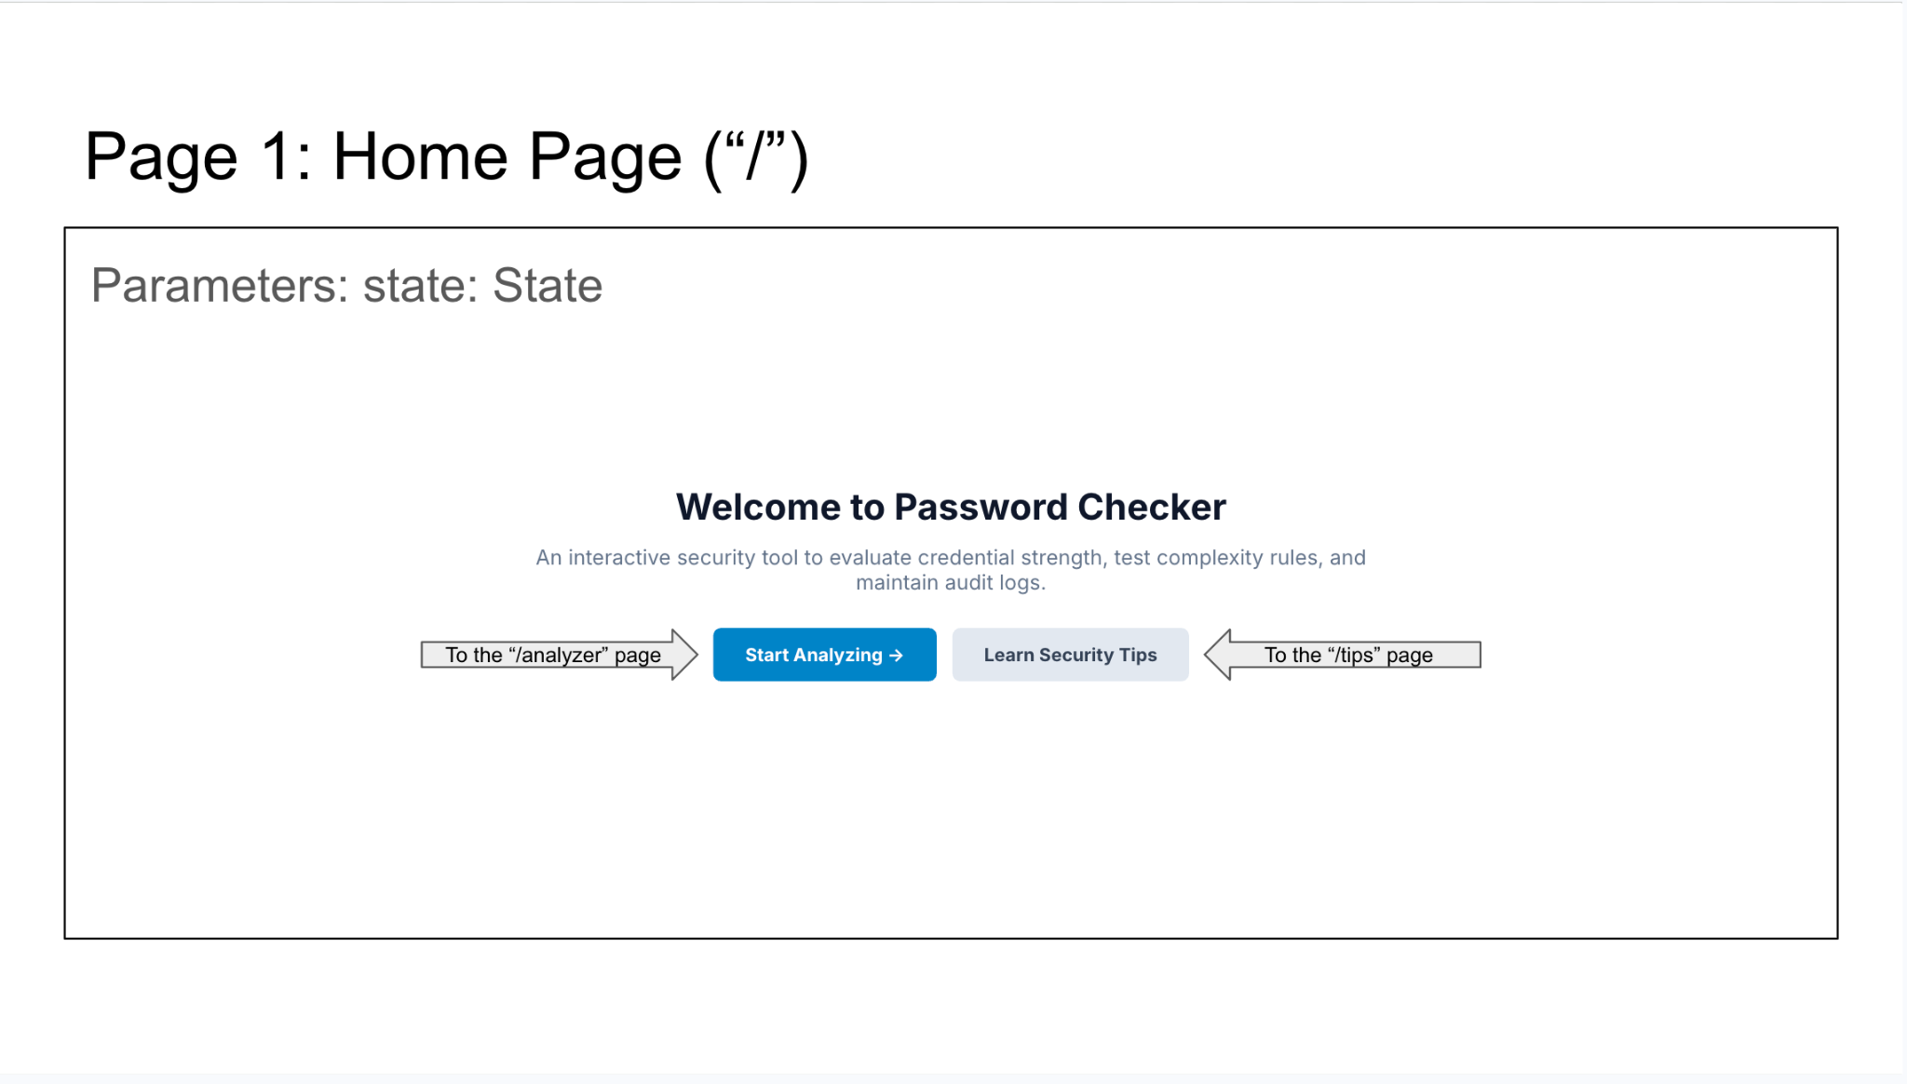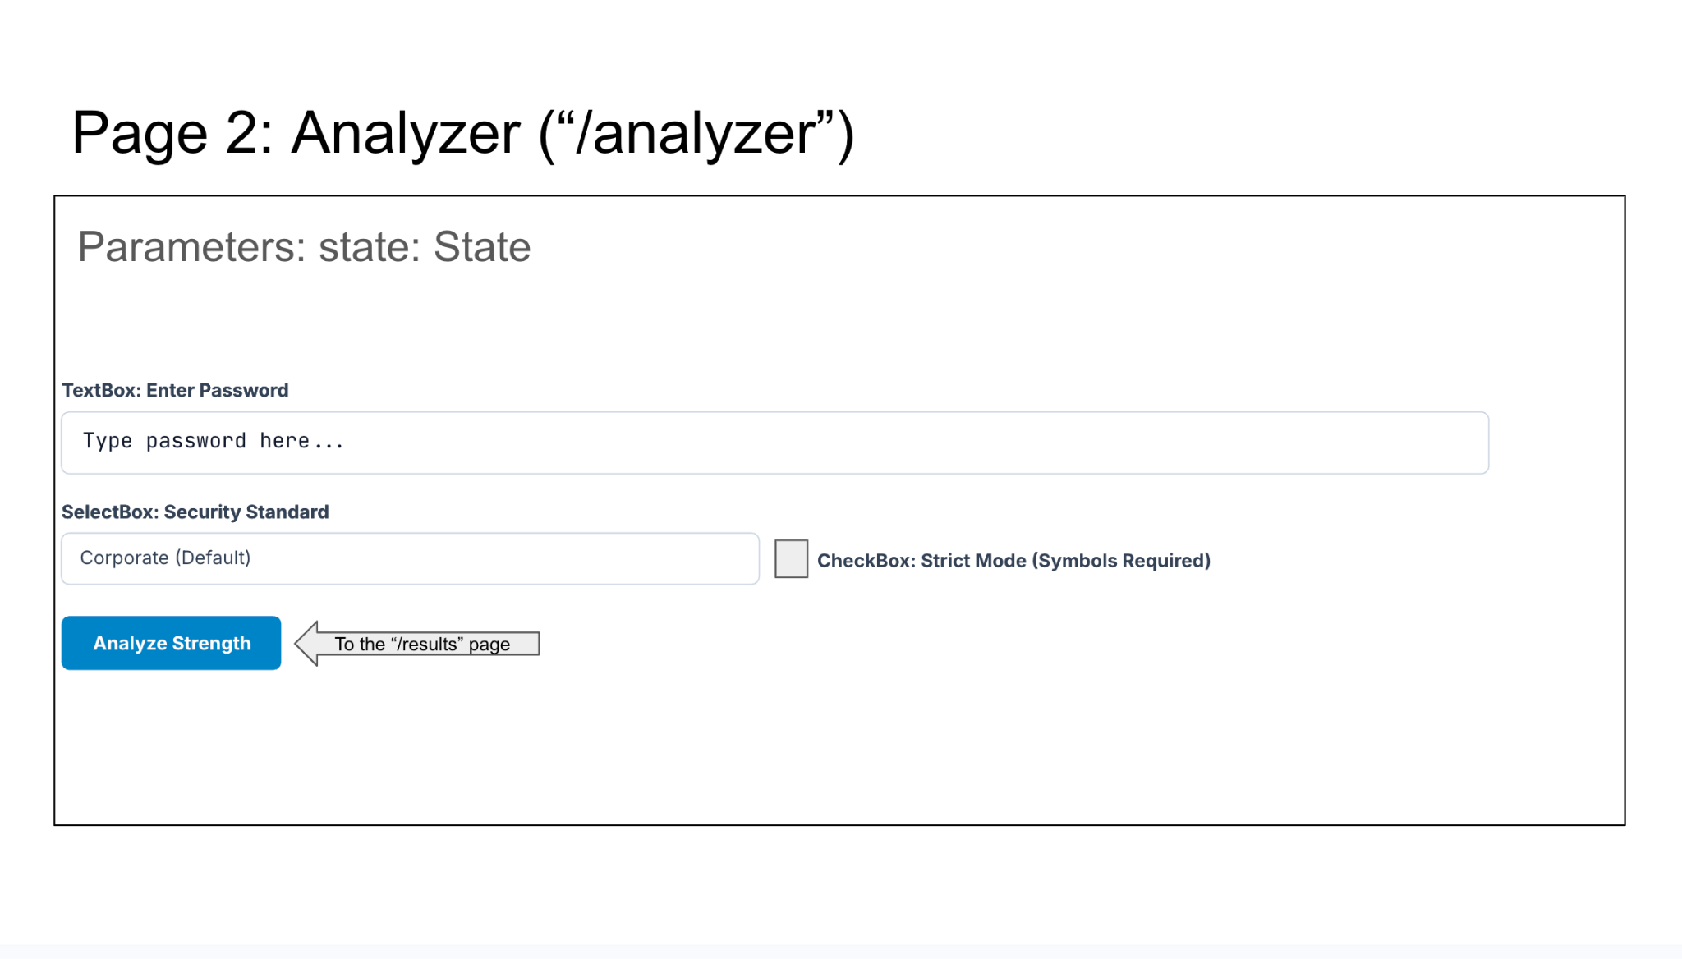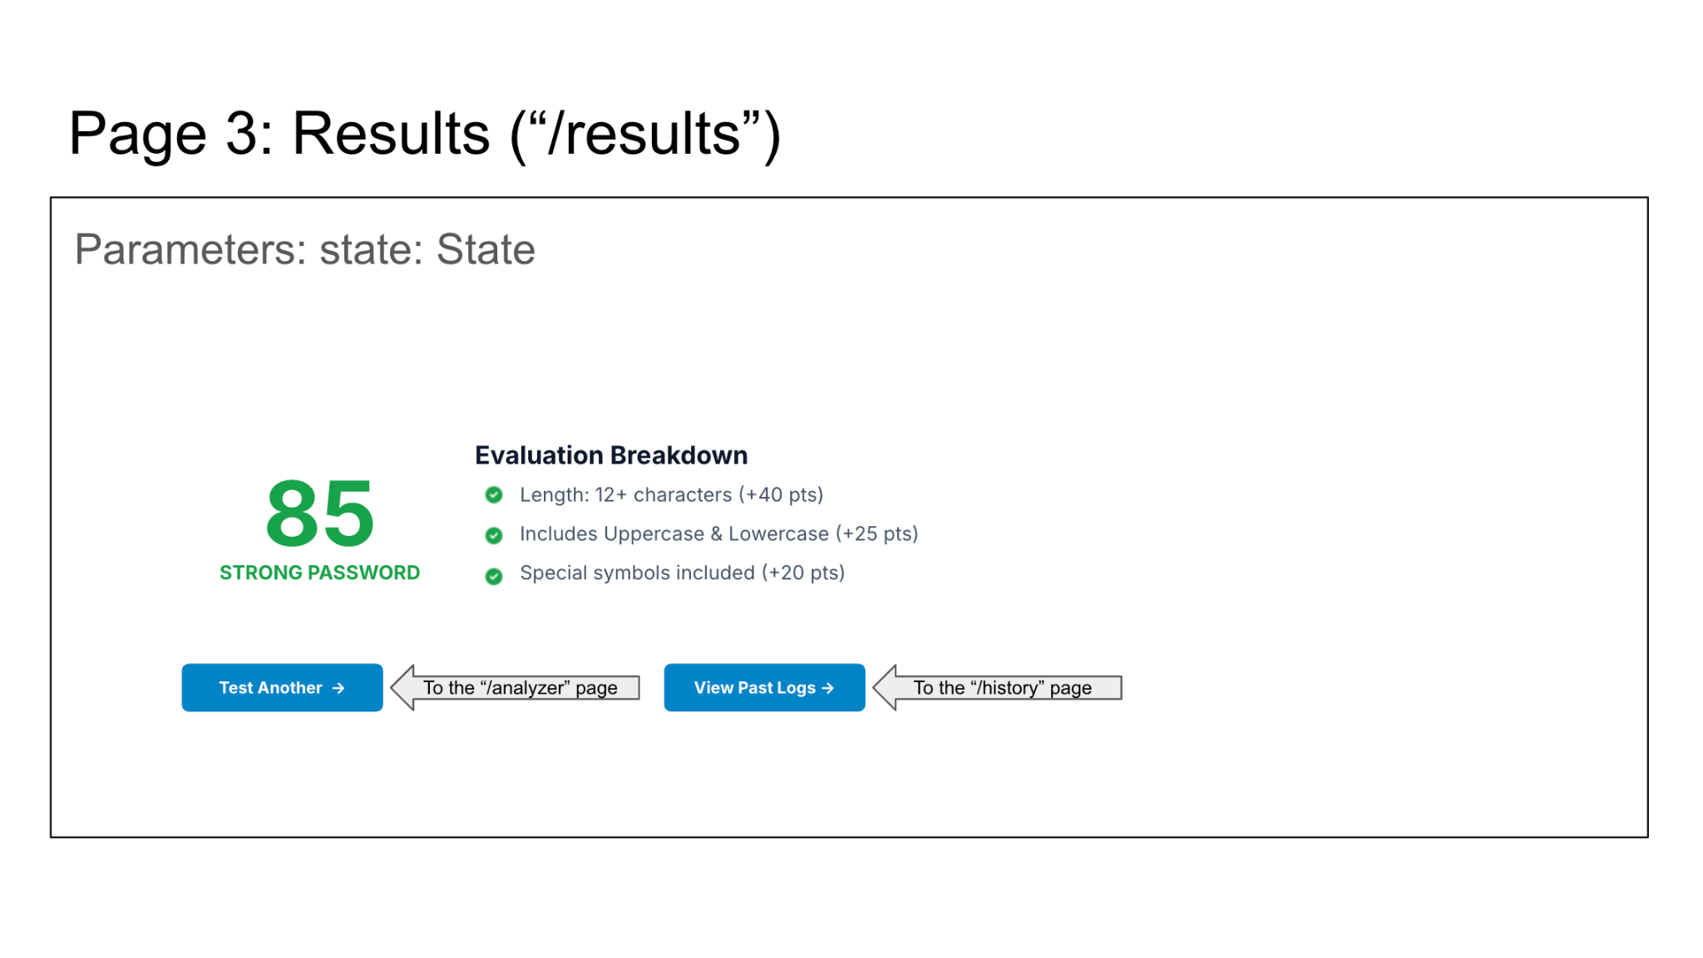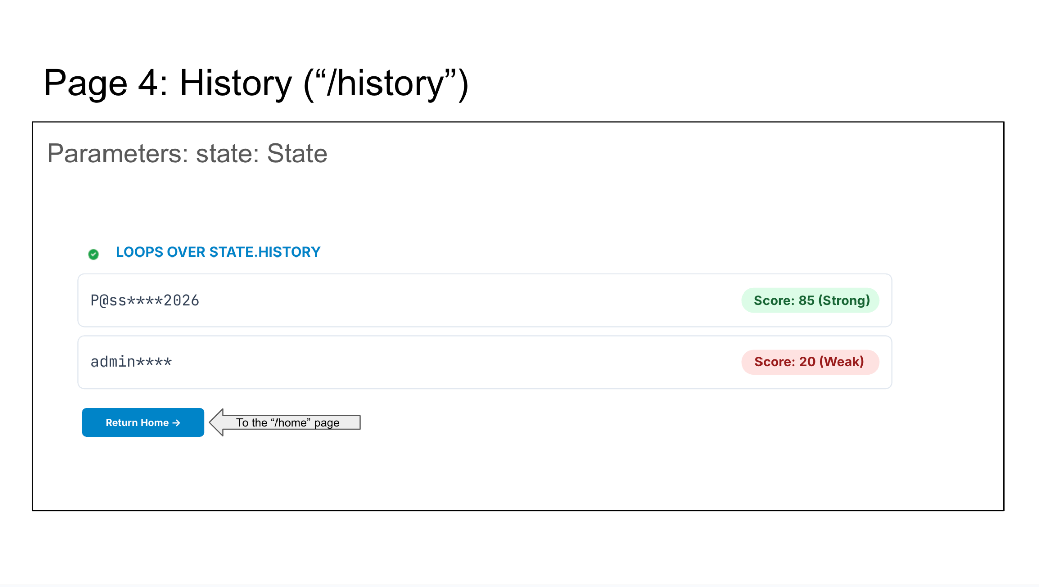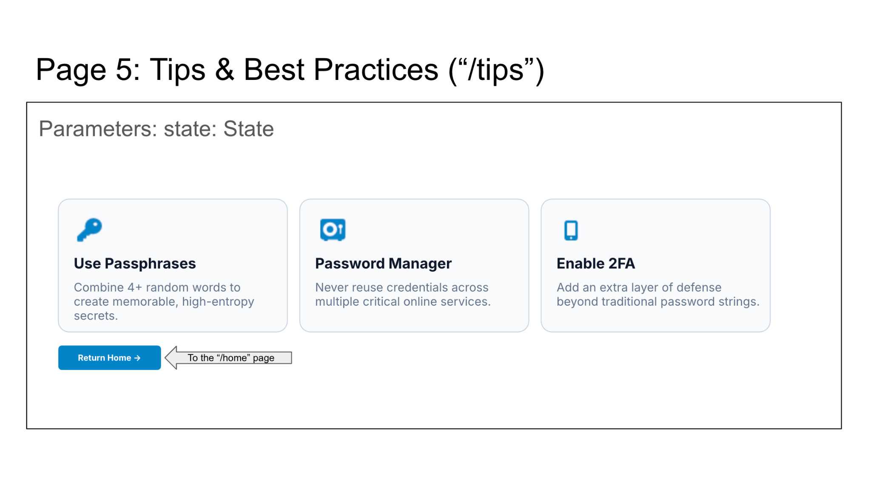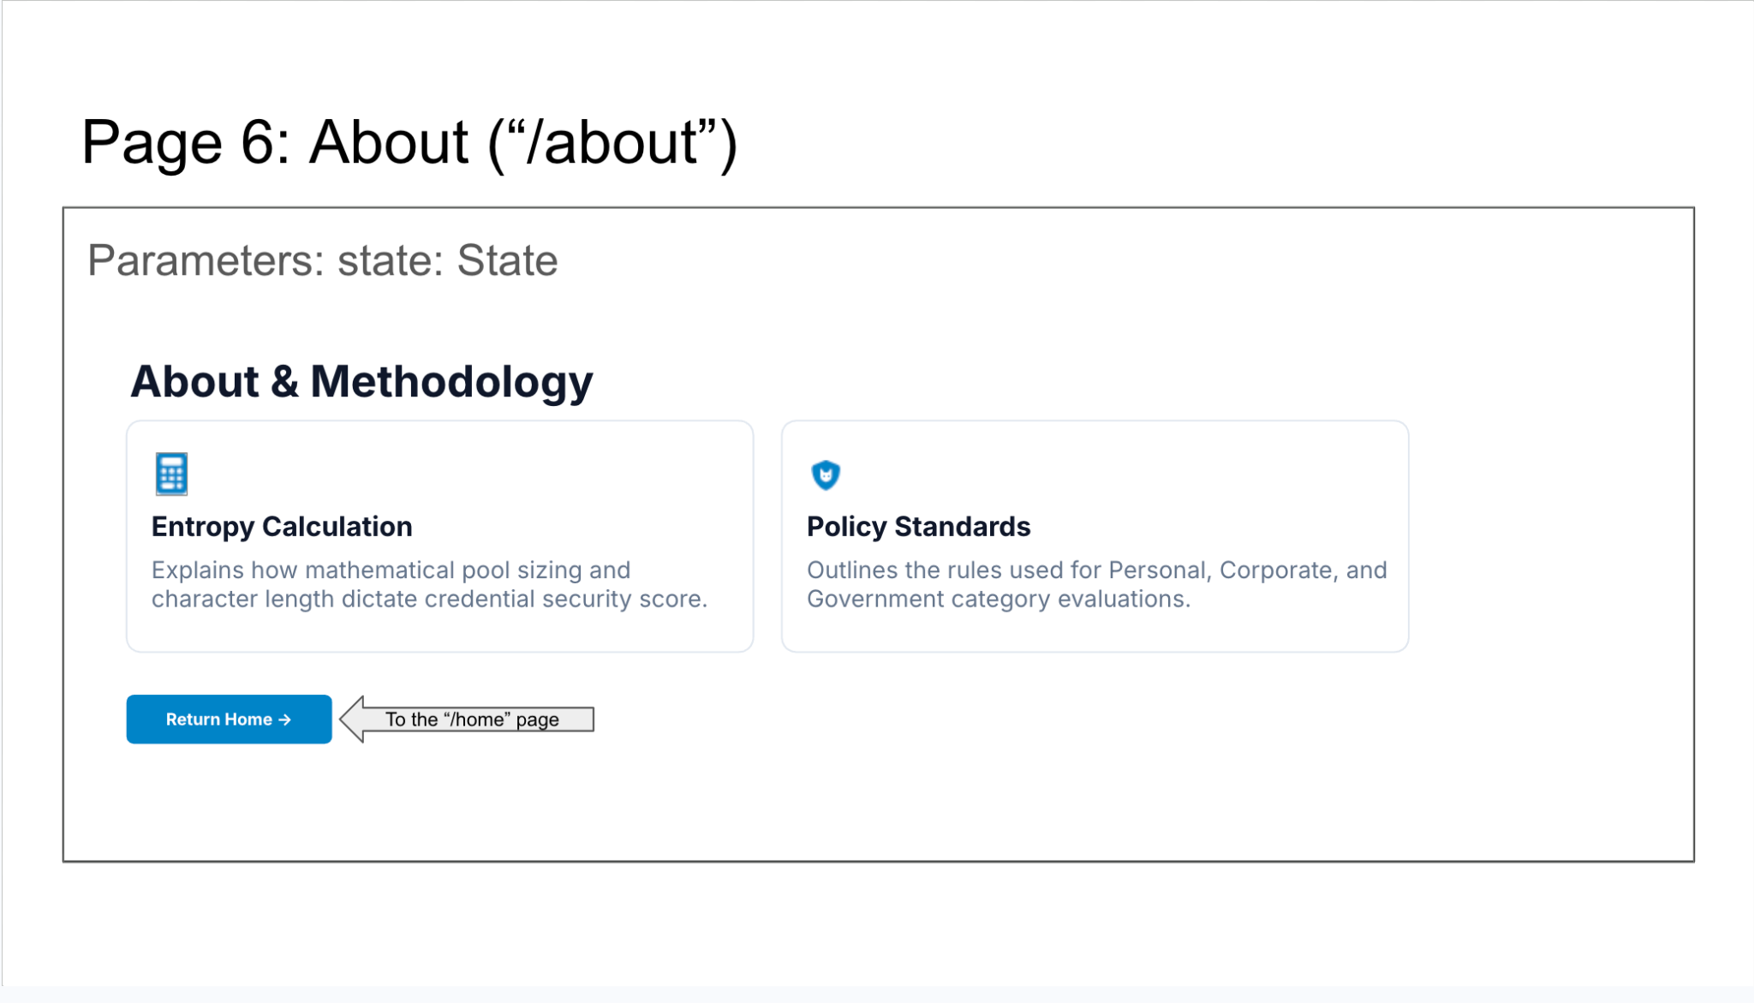
2) Implementing Requirements
This table should serve as a draft for how you will implement the requirements into your final project. You may change your ideas later on, but your final site must fulfill all the requirements.

Requirement | Implementation
Purpose/Functionality  A 1-2 sentence description of the purpose or functionality of your site | This website is an interactive website that allows users to evaluate password strength in real-time, showcase the brute-force time to crack, and maintain a persistent history log of past analyzed passwords.
State Dataclass Attributes  Minimum of 4 attributes, one of which must be a list/dict of instances of your second dataclass.  Briefly describe each attribute, its type, and how it will be meaningfully modified throughout the site. | State Dataclass:  current_password: (str): Stores user input text entered in the main analyzer input field.  history (list[PasswordRecord]): Persistent list storing instances of past analyzed passwords.  strict_mode (bool): Toggles strict validation rules (e.g., symbol enforcement).  active_category (str): Selected target rules to check the password strength (e.g., "Personal", "Corporate", "Government").
Second Dataclass  Your second dataclass, including its attributes, their types, and how they will be meaningfully modified (if they are modified) | PasswordRecord Dataclass:  masked_password (str): Partially obscured version of the password for privacy with “***” (e.g., P@ss****).  score (int): Security rating calculated during analysis (0 to 100).  rating_label (str): Summary evaluation string (e.g., "Weak", "Moderate", "Strong").
Routes (minimum 7)  The names of your route functions | - index  - analyzer  - results  - history  - tips  - about  - clear_history
Pages (minimum 5)  A brief description of the pages in your site | - Home Page: The main screen that welcomes the user and is introducing the tool with navigation links to the other pages.  - Analyzer Page: This page is the main nterface with input boxes to enter a password and configuration settings for a user to then analyze their password.  - Results Page: This page showcases a detailed breakdown displaying the security score of the analyzed password and feedback for improvements.  - History Page: This page is meant to log and view past password evaluations, you may choose to delete these analyses .  - Tips Page: This page serves as an educational guide on creating safe and secure passwords for cyber safety.  - About Page: This page will detail information on the creator of the website, and the methods of calculation used in the website.
User Input (minimum 3)  Description of user input components (TextBox, TextArea, CheckBox, or SelectBox) and their purposes  For more information on these input types, see Drafter Documentation. | - TextBox: This TextBox on the “/analyzer” page allows the user to input the password they want to test.  - CheckBox: This CheckBox on the “/analyzer” page toggles strict enterprise compliance rules that will be decided by the SelectBox.  - SelectBox: This SelectBox on the “/analyzer” lets the user select their target security environment (Personal, Corporate, Government). These will all have different requirements for the password with increasing difficulty to satisfy the requirements.
If Statements (minimum 3)  Brief description of what will be evaluated in your if statements and how they will meaningfully change the logic of the site | - Determines if the password length is below 8 characters to immediately apply a severe penalty score during the all three of the categories.  - Checks if strict_mode is enabled to turn on the category requirements like special symbols in the validation checks.  - Checks if the history list of the old password analyzed is empty to either display the past records or a placeholder message saying to do the first analyzation .
Loop (minimum 1)  This loop must iterate over the list/dict of dataclass instances in your State attribute.  Description of this loop and why it is meaningful to the site | - The loop would iterate over state.history during the history route to then dynamically generate cards displaying the old analyzations. These cards would incorporate the fields masked_password, score, and rating_label.

LLM Conversation
If you used an LLM in any part of this work, copy and paste every part of that conversation below. Otherwise, you may be given a zero for the assignment. Obviously, these words will not all be yours, and this is the exception to the requirement at the top of this assignment that all responses be in your own words. If you did not use an LLM to assist you in this assignment, simply say so below.
I did not use an LLM to assist me with the assignment.

Final Submission
When you are finished, download this file as a Word Document (docx) and upload the file to the appropriate assignment on Canvas.

